RazorHack 2024

Writeup

“S-43x19-22 Await

Further Instructions…”

Chaz has lost all of his devices a couple of days ago before going off to a Chappel Roan Concert... He has a bad memory, but he thinks that it is stuck to something around you... Also weirdly around the same time, some of the signs had a weird small-signal frequency coming off of them...

Author: Thomas

In this challenge, NFC (Near Field Communication) tags were placed on the top-right hand corner of most of the signs around the competition area. Since most modern cell phones have access to an internal NFC antenna inside of them, an application can be downloaded from an app store. For this challenge, I used the “NFC Tools” app to check the tags. The mobile application icon looks like the following image.

Once the application was open, the “read” option was selected. This is shown in the following image:

After that, the phone was placed near to the NFC tag and the information was read off it (Sometimes it take more than one try using the NFC reading application). When the information was read off it, the data screen on NFC Tools would look like:

This contains all the information about the device, but we are only concerned with the data on the device. So, the “Record 1 – Text” tab at the bottom of the page was selected and the data page was opened.

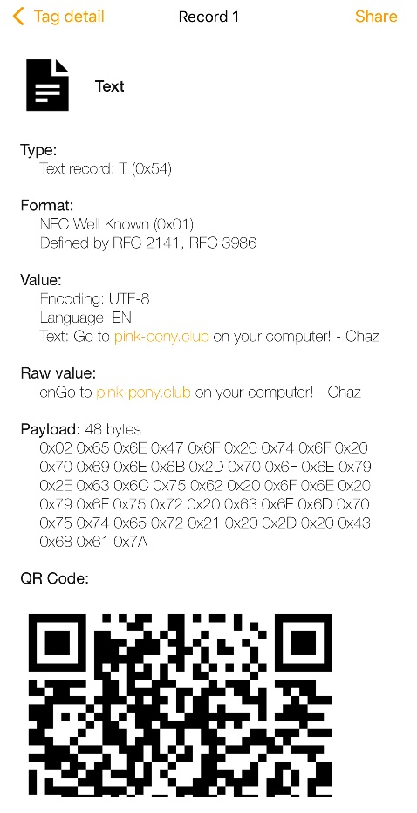

On this application page, it contained the text “Go to pink-pony.club on your computer! – Chaz”. Going to pink-pony.club in the web browser will open the following website:

From this initial page on the website, the flag (**flag{1_L0V3_NFC_tags_564r65a836p89}) is shown to the user.**

**Note: The website was blocked from the University of Arkansas’ network, so the competitors were asked to use an external network (like a mobile phone hotspot) or to use a VPN (Virtual-Private Network). If implemented in the future make sure that the website works with the network on the day of the CTF.**